
Dashboard Design

Date | 2 November 2026
Team ID
Project Name | Global EV Market Intelligence Dashboard
Maximum Marks | 5 Marks

Activity 1: Interactive and visually appealing dashboards
Creating an effective Streamlit dashboard involves presenting business data stored in Snowflake through clear, interactive, and easy-to-understand visualizations. Students should design the dashboard so that users can quickly understand important KPIs, trends, comparisons, and business insights.
- Clear and Intuitive Layout
- Use Appropriate Visualizations
- Colour and Theming
- Interactive Filters and Slicers
- Drill-Down Capabilities
- Responsive Design
- Custom Visuals and Icons
- Use of Infographics

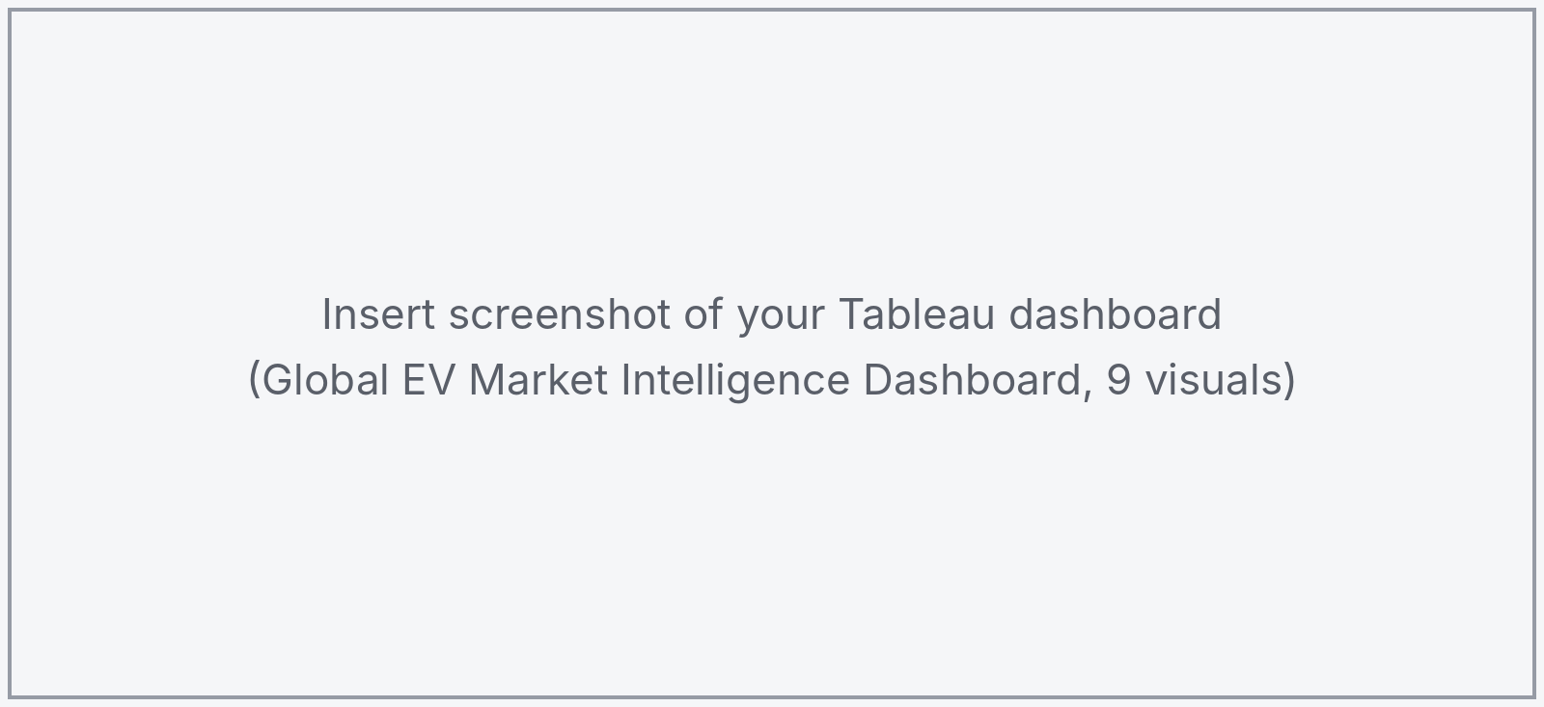

Note: Highlight the major outcomes in form of bullet points
Major outcomes:
Here are five major outcomes from the dashboard:
- A few categories drive most of the sales
Two-Wheeler Scooter (260M), Sedan (232M), Hatchback (231M), Compact SUV (230M) and Three-Wheeler (200M) make up about half of the 2.32B units sold, while Electric Bus, Pickup and Electric Truck sell only 16–20M each.
- Range depends mainly on vehicle category
Luxury Sedan (550 km), Luxury SUV (525 km) and Full-size SUV (475 km) have the longest range; Three-Wheeler (130 km) and Two-Wheeler Scooter (105 km) the shortest. Capacity and range are only weakly related (correlation about 0.27).
- NMC and LFP dominate battery adoption
NMC (33.7%) and LFP (32.0%) hold about two thirds of sales, followed by NCA (17.3%), Sodium-Ion (9.9%) and Solid-State (7.1%). Range, capacity, charging time and price are nearly the same across battery types (about 323–326 km).
- Manufacturers, countries and ratings are very evenly matched
The top manufacturer, AmpereWorks, has only 0.59% share among 200 manufacturers; China (237M) and Japan (227M) differ by about 4%; ratings stay between 4.05 and 4.13.
- Growth between 2018 and 2026 is very small
Two-Wheeler Scooter grows +0.65% per year, Full-size SUV +0.49% and Pickup +0.45%, while Van/MPV (−1.2%) and Micro City Car (−1.1%) decline. No segment shows strong growth.
Overall outcome: The dashboard shows that EV sales and range are shaped mainly by vehicle category and battery type, while manufacturers, manufacturing countries and customer ratings are very similar, so there are no strong competitive advantages or high-growth segments in this data (the dataset appears synthetic).

